AI Automation Ladder Platform
Technical Detailed Design Document
CTO-ready technical design for a modular nonprofit gift intelligence platform built around the Automation Ladder maturity model.
Prepared For | Prepared By | Use Case | Date
Internal product strategy / client deployment planning | OpenAI draft based on meeting notes and source documentation | Initial delivery focus: Les Turner | March 19, 2026

Executive summary. The platform should be designed as a modular, client-configurable system that ingests fragmented gift inputs, structures them into a canonical model, applies contextual intelligence using CRM and document knowledge, routes or automates decisions under policy control, and writes final outcomes into the target CRM or finance system. The meeting clarified a critical architectural requirement: production value is not complete until the final record is posted into the operational system of record.

1. Purpose and Scope
This document defines the target technical design for the AI Automation Ladder platform, with an immediate implementation focus on nonprofit gift processing and a product architecture that can expand into knowledge automation and governed decision automation for future clients.
The initial deployment strategy prioritizes Les Turner as the first production use case because it provides a lower-volume, lower-stakes environment while still exposing the core technical challenges that the product must solve. At the same time, the architecture intentionally anticipates broader enterprise scenarios such as fund restriction intelligence and capital availability reasoning.
• In scope: multi-source intake, OCR/LLM extraction, normalization, review queues, knowledge retrieval, policy evaluation, human approval paths, target-system posting, and audit logging.
• Out of scope for phase 1: full enterprise-grade restriction reasoning, cross-client generalized semantic models, and direct automation of every complex gift exception on day one.
2. Business Drivers
• Gift data arrives through fragmented channels including emails, spreadsheets, CSV exports, PDFs, scanned paper mail, portals, and external vendor systems.
• Operations teams manually interpret these inputs, re-enter data into fundraising systems, and apply organization-specific fund and restriction logic.
• The same gift may appear through duplicate signals such as an email alert plus a portal export.
• Institutional knowledge required to classify gifts often lives outside the CRM in gift agreements, operational documentation, and staff memory.
• The platform should improve not just gift entry throughput, but also future visibility into fund restrictions, fund availability, and policy-aware decision support.
3. Design Principles
• Modular by default: every client has different sources, CRM systems, policies, fund structures, and document landscapes.
• Cumulative ladder delivery: Level 1 creates structured data, Level 2 creates contextual understanding, and Level 3 enables governed action.
• Human-centered control: the platform must support review, override, exception handling, and explainable recommendations.
• Last-mile completeness: the solution is operationally incomplete until the final gift record reaches the target system.
• Traceability over opacity: every extraction, recommendation, override, and posted action must be auditable.
4. Target Operating Model
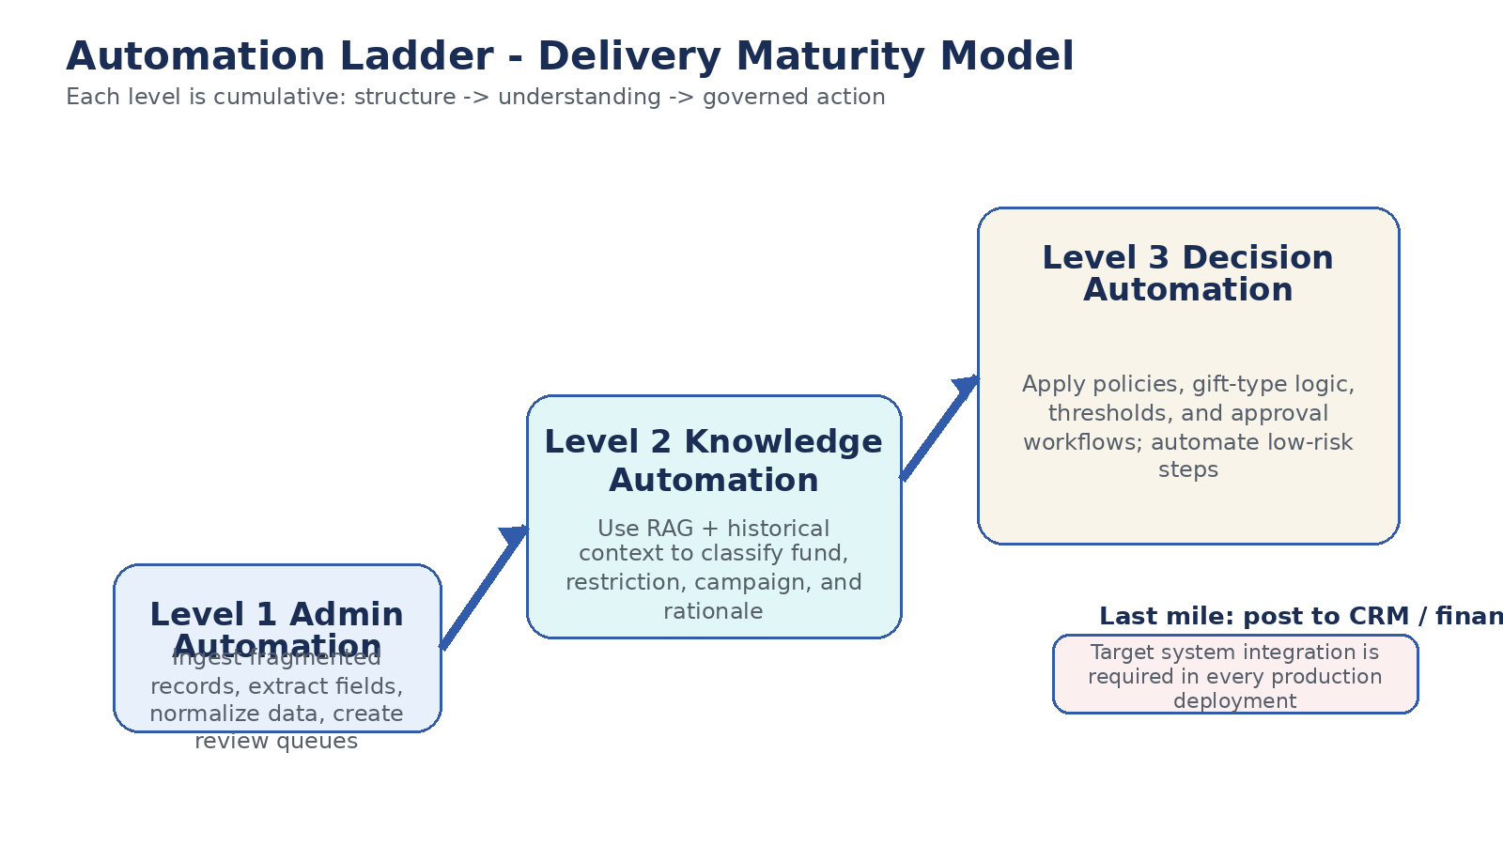
Figure 1. Automation Ladder delivery model with production emphasis on target-system posting and audit traceability.
5. End-to-End Architecture
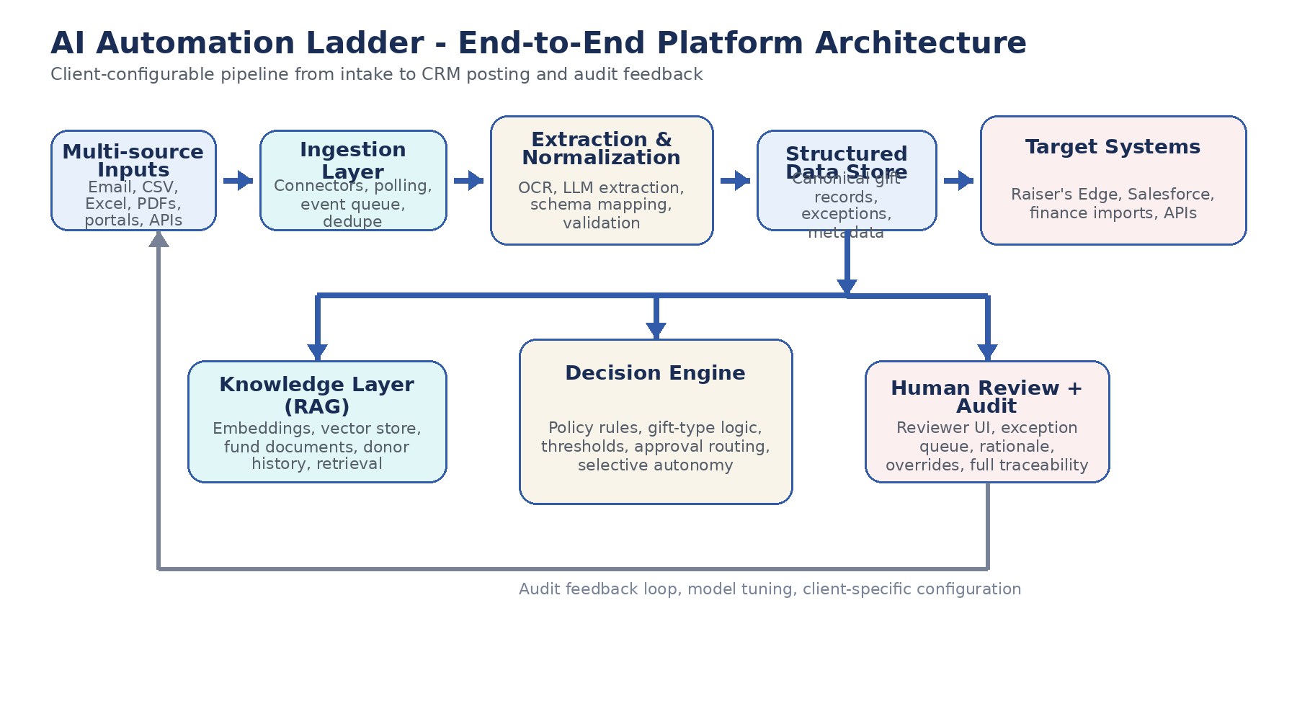
Figure 2. End-to-end platform architecture from heterogeneous intake through decisioning, review, posting, and feedback.
6. Core Platform Components
Component | Role | Key Capabilities
Multi-source ingestion layer | Acquire incoming data from email attachments, shared folders, portal downloads, API connectors, and manual uploads. | Email/Graph/IMAP listeners, file watchers, API adapters, polling jobs, event queue, deduplication pre-checks.
Extraction and normalization engine | Convert heterogeneous source payloads into a canonical gift record and queue exceptions. | OCR, LLM extraction, schema mapping, source-specific parsers, confidence scoring, validation rules, exception routing.
Structured data store | Persist normalized records, source metadata, and workflow state for downstream processing. | Relational database, raw payload retention, lineage keys, status tracking, canonical gift model.
Knowledge layer | Combine CRM data, donor history, fund metadata, gift agreements, and other documents into retrievable context. | Embedding pipeline, vector store, retrieval orchestrator, metadata filters, semantic grounding.
Decision engine | Apply gift logic and policy controls to recommend or automate next actions. | Policy rules engine, thresholds, gift-type branching, approval routing, risk scoring, rationale generation.
Human review and audit layer | Present explainable recommendations, support override actions, and retain full traceability. | Reviewer UI, exception workbench, audit event store, approval actions, feedback capture.
Target system integration layer | Write final outcomes into CRM, finance, or import workflows. | CSV/export generators, API connectors, mapping templates, delivery acknowledgements, retry controls.

7. Level 1 - Admin Automation Design
Level 1 establishes the intake and processing backbone. This is the immediate product priority for Les Turner. The objective is not to solve every difficult gift scenario on day one, but to create meaningful operational efficiency by letting machines handle structured extraction and humans handle ambiguity.
• Primary inputs: email attachments, portal exports, CSV files, spreadsheets, PDFs, and representative samples of paper mail or scanned collateral.
• Main outputs: canonical gift records, admin dashboard entries, review queue items, exception queue items, and import-ready files for the destination system.
• Critical technical challenge: duplicate source signals, such as an email notice that points users to a portal where the same gift details can also be downloaded.
Canonical gift record
Field | Description
gift_id | System-generated unique identifier for the normalized record.
source_channel | Email, portal, API, manual upload, shared folder, or other intake route.
source_system | Vendor or platform name such as Stripe, Fidelity, CyberGrants, DAF provider, or donor mail.
source_file_id | Unique identifier or checksum for the incoming file/object.
donor_name | Parsed donor or legal source name.
amount | Normalized monetary amount.
gift_date | Effective gift date or received date based on source rules.
payment_type | Cash, stock, ACH, wire, check, card, or other.
gift_type | Gift, pledge, pledge payment, stock gift, matching gift, tribute, and related variants.
memo | Free-text memo or extracted purpose language.
raw_payload_ref | Reference to original file/blob and extracted text.
status | New, review required, approved, posted, rejected, duplicate, or exception.
8. Level 2 - Knowledge Automation Design
Level 2 introduces contextual understanding through retrieval-augmented generation. The meeting clarified that the CRM is only part of the knowledge surface. In many client environments, the authoritative meaning of funds and restrictions lives in gift agreements, side documentation, and operating notes rather than in clean CRM fields.
• Build a client-specific knowledge layer rather than a one-size-fits-all semantic model.
• Ingest CRM fund metadata, donor history, coding patterns, gift agreements, restriction documents, and other supporting material.
• Create embeddings for documents and structured records where retrieval improves classification quality.
• Return not only a suggested classification, but also confidence scores and rationale grounded in evidence.
Knowledge automation output contract
For each candidate gift, the system should return a structured recommendation package:
• suggested_fund
• suggested_campaign
• suggested_appeal
• suggested_restriction_status
• confidence_score
• supporting_evidence
• rationale_text
• review_required_flag
9. Level 3 - Decision Automation Design
Level 3 combines structured gift data, contextual interpretation, and policy controls to recommend or selectively automate next actions. This layer should be implemented with conservative guardrails. The goal is governed decision support, not uncontrolled autonomy.
• Decision dimensions: policy compliance, risk thresholds, confidence thresholds, gift-type workflow branching, and continuity with prior agreements.
• Gift logic explicitly called out in the meeting: regular gifts, pledges, pledge payments, tribute gifts, matching gifts, soft credits, and stock gifts.
• Stock gift handling: support branch logic for valuation, liquidation assumptions, accounting treatment, and pledge-offset scenarios.
10. Human Review Modes
Mode | Operational intent
Suggest Mode | AI proposes actions; a human reviewer approves or edits every result.
Assist Mode | AI pre-fills coding and workflow actions while a reviewer finalizes the record.
Auto Mode | System executes low-risk actions only when policy and confidence thresholds are satisfied.
Audit Mode | System flags anomalies, policy conflicts, or uncertain cases for follow-up.
11. Last-Mile Integration Architecture
A major outcome from the meeting was the explicit recognition that the platform must include the final posting step into the system of record. Extraction and recommendation alone do not complete the gift-entry lifecycle.
• Phase 1 integration pattern: generate validated import-ready files for the target CRM, with controlled mappings and posting status tracking.
• Future integration pattern: support direct API-based posting into CRM and finance platforms where clients provide access and production readiness allows.
• Integration reliability controls: mapping templates, schema versioning, retry handling, acknowledgement capture, and reconciliation reporting.
12. Client Configuration Model
• Source adapters: which inboxes, folders, portals, or APIs are monitored.
• Schema mappings: how vendor-specific fields map into the canonical gift model.
• Knowledge sources: which CRM tables, documents, and metadata repositories should be indexed.
• Policy profiles: thresholds, approval logic, sanctions/compliance checks, and gift-type rules.
• Posting targets: file format specifications, API credentials, import schedules, and downstream acknowledgements.
13. Security, Governance, and Audit
• Client data isolation across environments.
• Secret storage in a cloud key vault or equivalent secrets manager.
• Role-based access controls for admin, reviewer, approver, and audit users.
• Full event-level audit trails for extracted fields, model outputs, human overrides, and posted transactions.
• Encrypted storage for raw documents, extracted text, and staging records.
14. Suggested Technology Stack
Layer | Recommended stack
API and workflow orchestration | FastAPI, Python services, queue-based workers
OCR and extraction | Azure Document Intelligence plus OpenAI extraction prompts
Knowledge retrieval | Embedding pipeline with Pinecone, Weaviate, or equivalent vector store
Structured storage | PostgreSQL or SQL Server for normalized operational records
Decision and policy layer | Python rules engine plus LLM orchestration for rationale generation
Review interface | Retool, Streamlit, or lightweight custom web UI
Observability | Structured application logs, audit event tables, and monitoring dashboards
15. Delivery Roadmap
Phase | Primary deliverables | Indicative timing
Phase 1 - Les Turner intake backbone | Source manifest, representative sample collection, ingestion adapters, extraction pipeline, canonical gift model, exception queue, import-ready output files. | 2-4 weeks
Phase 2 - Knowledge automation | Client-specific knowledge ingestion, fund metadata retrieval, donor history linkage, evidence-backed classification outputs. | 4-6 weeks
Phase 3 - Decision automation | Policy engine, gift-type branching, approval workflows, selective low-risk automation, review console hardening. | 6-10 weeks
Phase 4 - Strategic intelligence | Restriction reasoning, fund availability analysis, broader enterprise reporting and optimization use cases. | Future
16. Risks and Mitigations
Risk | Why it matters | Mitigation approach
Source heterogeneity | Every vendor and channel has different file structures and edge cases. | Use source-specific parsers behind a canonical model and onboard sources iteratively.
Duplicate detection | The same gift may surface through multiple notices and downloads. | Use checksums, reference IDs, date/amount matching, and source dedupe rules.
Incomplete knowledge in CRM | Authoritative restriction meaning often lives outside the CRM. | Ingest gift agreements and supporting documents into the knowledge layer.
OCR variability | Scanned paper and historical agreements may be noisy or partially readable. | Combine OCR confidence thresholds, review queues, and selective manual validation.
Client-to-client variation | Policies, fund structures, and system integrations differ materially. | Make connectors, mappings, and policy packs configurable rather than hard-coded.
17. Immediate Next Steps
• Create the Les Turner working channel and weekly working session cadence.
• Assemble a source manifest listing all gift channels and representative sample files used by gift-entry staff.
• Collect safe sample inputs without sharing sensitive scanned checks or unnecessary donor PII.
• Confirm the initial target output format required by the destination CRM or import process.
• Identify the first-pass SME group for fund logic, gift types, and policy interpretation, including Mike as subject-matter advisor.
18. Conclusion
This design turns the Automation Ladder from a conceptual framework into a buildable product architecture. The immediate delivery should focus on reliable intake, extraction, normalization, and import-ready outputs for Les Turner. The architecture, however, should be implemented in a way that preserves the higher-value trajectory: client-specific knowledge automation, governed decisioning, and eventually deeper restriction intelligence that helps organizations understand not only how to process gifts, but how to reason over the funds they already hold.

Source basis: meeting transcript dated March 19, 2026 and the existing AI Automation Ladder platform specification document.

